1.One-time setup on your Terraform (Amazon Linux 2) server
sudo yum install -y jq
mkdir -p /opt/scripts
mkdir -p /opt/terraform/logs
Make sure AWS CLI is already configured (role or aws configure).
2.Create the main script
Create file: /opt/scripts/collect_all_resources.sh
sudo chmod +x /opt/scripts/collect_all_resources.sh
Test it once manually - /opt/scripts/collect_all_resources.sh
Then check: ls -R /opt/terraform/logs
see something like: /opt/terraform/logs/2025-01-14/
1074_ap-south-1_prod-vpc_allresources_2025-01-14.sot
1074_ap-south-1_non-prod-vpc_allresources_2025-01-14.sot
3.Validate what’s inside the log file
cd /opt/terraform/logs/2025-01-14/
Now view one .zipfile:
cat 1074_ap-south-1_prod-vpc_allresources_2025-01-14.zip
see ===== EC2 INSTANCES =====(table of EC2 details) ===== SUBNETS ===== (table of
4.Enable automatic DAILY creation
sudo crontab -e
replace with it
# Run daily at 17:00 server time
0 17 * * * /opt/scripts/collect_all_resources_master.sh >> /var/log/collect_daily.log 2>&1
Verify the crontab entry: sudo crontab -l
Run the script as root #this is created as root so when ever needed check by root user - neeraja@ip-11-0-1-154 etc]$ sudo crontab -l
sudo /0 10 * * * /opt/scripts/collect_all_resources_master.sh >> /var/log/collect_all_resources_master.log 2>&1
optional - If you still get permission denied, run this to verify file exists:
ls -l /var/log/collect_daily.log
If the file does not exist, create it with root:
sudo touch /var/log/collect_daily.log
sudo chmod 644 /var/log/collect_daily.log
Now rerun:
sudo /opt/scripts/collect_all_resources.sh >> /var/log/collect_daily.log 2>&1
----------- Now your server collects AWS resource logs DAILY ----------
Go to your repo directory:
Clone https into this dir on server
Mkdir infra-terraform-sot -- go into it
cd /opt/terraform/infra-terraform-sot
Make sure you are on the correct branch
Your repo uses master, not main.
git branch –- master
Pull remote changes FIRST (required)
This step syncs your server with Bitbucket:
git pull origin master
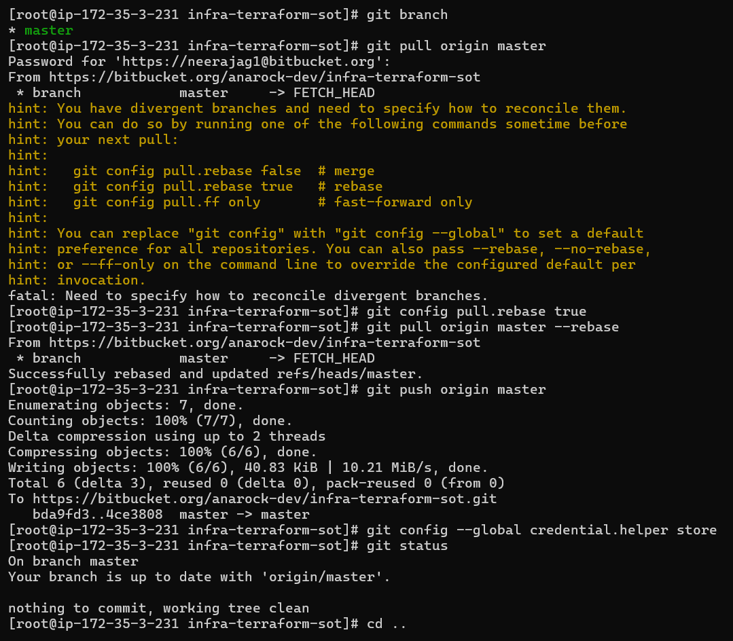
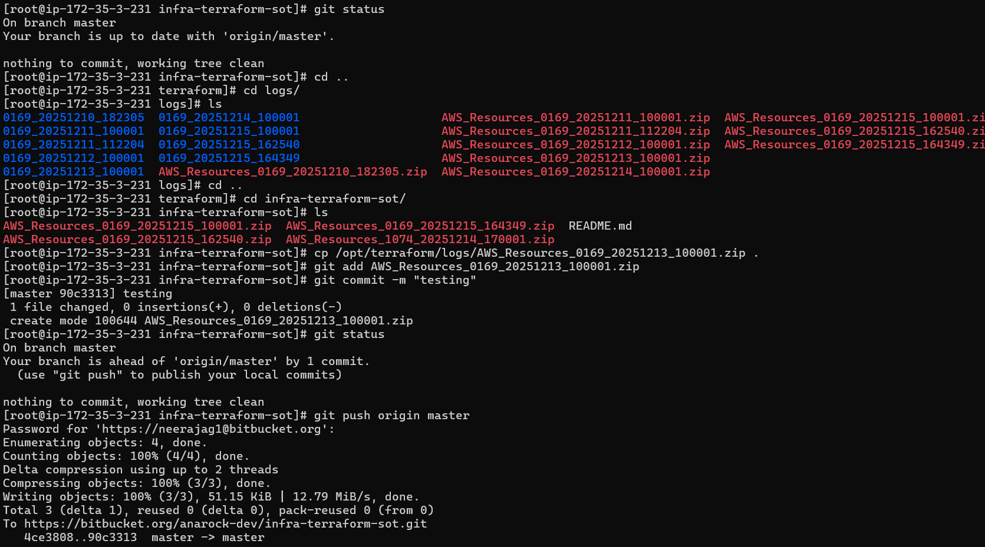
Now push again (this will work)
git push origin master
Since this repo is ONLY for daily ZIP backups, the correct strategy is:
Always rebase when pulling
(no merge commits, clean history, automation-safe)
Run ONCE on the server:
cd /opt/terraform/infra-terraform-sot
git config pull.rebase true
Or globally (recommended for automation servers):
git config --global pull.rebase true
This answers Git’s question forever.

NOW FIX THE CURRENT STATE (DO THIS ONCE)
Run:
cd /opt/terraform/infra-terraform-sot
git pull origin master --rebase
Then:
git push origin master
This will succeed
No more errors
Repo is now clean and aligned
OPTION 1 (BEST): AWS SES SMTP (most reliable)
🔹 Step 1: Create SMTP credentials (one-time)
In AWS SES → SMTP settings → Create SMTP credentials
You will get:
- SMTP username
- SMTP password
- SMTP endpoint
Example:
- email-smtp.ap-south-1.amazonaws.com

🔹 Step 2: Install required packages on EC2
sudo yum install -y postfix cyrus-sasl cyrus-sasl-plain mailx

🔹 Step 3: Configure Postfix to use SMTP relay
Edit:
sudo vi /etc/postfix/main.cf
edit in this main.cf also :25
Add at the bottom:
relayhost = [email-smtp.ap-southeast-1.amazonaws.com]:25
smtp_sasl_auth_enable = yes
smtp_sasl_security_options = noanonymous
smtp_sasl_password_maps = hash:/etc/postfix/sasl_passwd
smtp_use_tls = yes
smtp_tls_security_level = encrypt
smtp_tls_note_starttls_offer = yes
🔹 Step 4: Add SMTP credentials
sudo vi /etc/postfix/sasl_passwd
Add exactly:
[email-smtp.ap-south-1.amazonaws.com]:587 SMTP_USERNAME:SMTP_PASSWORD
Replace:
- SMTP_USERNAME
- SMTP_PASSWORD

🔹 Step 5: Secure & activate credentials
sudo postmap /etc/postfix/sasl_passwd
sudo chmod 600 /etc/postfix/sasl_passwd /etc/postfix/sasl_passwd.db

🔹 Step 6: Start & enable Postfix
sudo systemctl start postfix
sudo systemctl enable postfix

🔹 Step 7: TEST MAIL (this WILL work)
echo "Mail test from backup server" | mail -s "Mail Test" user1@company.com,user2@company.com
✅ If this works → SMTP is configured correctly.
---------------time change ---------
Check current timezone
timedatectl
You will see something like:
Time zone: UTC

🔹 STEP 5: Change timezone to IST
Run as root:
sudo timedatectl set-timezone Asia/Kolkata

🔹 STEP 6: Verify
date
timedatectl
Expected:
Time zone: Asia/Kolkata (IST, +0530)
----------cron fix-------
sudo crontab -e
0 8 * * * /opt/scripts/collect_all_resources_master.sh >> /var/log/collect_all_resources_master.log 2>&1
Check cron time – crontab -l
First I create /opt/scripts/vi collect_all_resources_master.sh
Pasted my script
Chmod

For removing this file from repo
git config --global --add safe.directory /opt/terraform/infra-terraform-sot
[neeraja@ip-172-35-3-195 infra-terraform-sot]$ git rm AWS_Resources_0169_20251216_100001.zip
git rm AWS_Resources_0169_20251216_100001.zip
git commit -m "cleanup old backup"
git push origin master / first pull then push

Collection of source : We have 3 regions and we have vpc in regions in vpcs we have production vpc, non-prod vpc , staging vpc, uat vac want all the vpc based on dates like sot , tmrw it should run the same with next date automatic . Common name like account_region_namevpc_ naming convention , we will have log file with date or sot data . 2.by using the data we have we will make dynamically.tmrw if we want to create or install ec2 I want to taken this data and create ec2 , which vpc, region , and all from existing one with simple build #my requirement

